**Checkpoint 1 documentation**

**VAN LINH HA**

**116592171**

Brief Contents

I. Install and Setup Windows Server 2012 R2 1

a. Install Windows Server 2012 R2 1

b. Basic setup 1

c. Install software 2

d. Install Local Network LAN Segment 2

e. Install DNS Server 3

II. Install and Setup Centos 7 as Client on VMware Workstation 4

a. Install Client Machine 4

b. Basic setup 4

c. Install software: 4

d. Grant permission to non-root user 5

e. Install Local Network LAN Segment 5

III. Install and Setup Linux Machines as Linux Server 6

a. Install Linux Server 6

b. Basic setup 6

c. Install software and update system 7

d. Grant permission to non-root user 7

e. Create a script to restart iptables 7

IV. Install and Setup Linux Machine as Router 8

a. Install Router Machine 8

b. Basic setup 8

c. Install software and update system 9

d. Grant permission to non-root user 9

e. Create a script to restart iptables 9

# Install and Setup Windows Server 2012 R2

## Install Windows Server 2012 R2

* Download the file image from MSDN website. Before start installing Windows Server, right click on VM, choose Setting. Add another Network Adapter. We have 2 network adapters, one for connecting to the Internet and another one for connecting to the Router.
* During Windows Server installation, all the these following information need to be assign correctly:
  + RAM: 4GB
  + Disk Space: 40GB
  + Time zone: GMT -5

## Basic setup

* Change the computer name

In Server Manager choose Local Server, click Computer Name, click Change and type Winserv in the computer name box. Click Apply and Ok.

* Change the IP address:
* IP: 195.165.17.70
* Subnet mask: 255.255.255.252
* GATEWAY: 195.165.17.69
* Preferred DNS: 195.165.17.70
* Turn off firewall: Turn off all the states of firewall

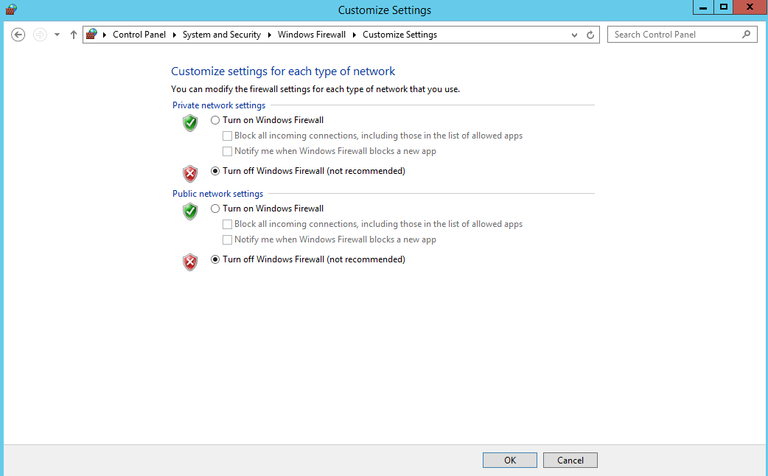

* Install Net Framework 3.5
* Add roles and features, click Next until reaching Feature. Choose .NET Framework 3.5 Features. Click Next and Install.

## Install software

* Download all of these following software from Internet and install it with default setting: Wireshark, Nmap

## Install Local Network LAN Segment

* Right click on VM and choose Setting, click Network Adapter, click Lan Segment, Click Add. Add 3 Lan Segment names:
  + **Router-Client**
  + **Router-Win-Server**
  + **Router-Lnx-Server**
* Assign Lan-Segment: Router-Win-Serv to Windows 2012 R2 machine.

## Install DNS Server

* In Server Manager, click Add Roles and Features. Click Next until reaching Server Roles. Select “DNS Server” and click on the box to tick it.
* Then it will prompt window to inform about the related additional features which DNS role need. click on "Add features" to continue.
* Click Next till the end and click Install.

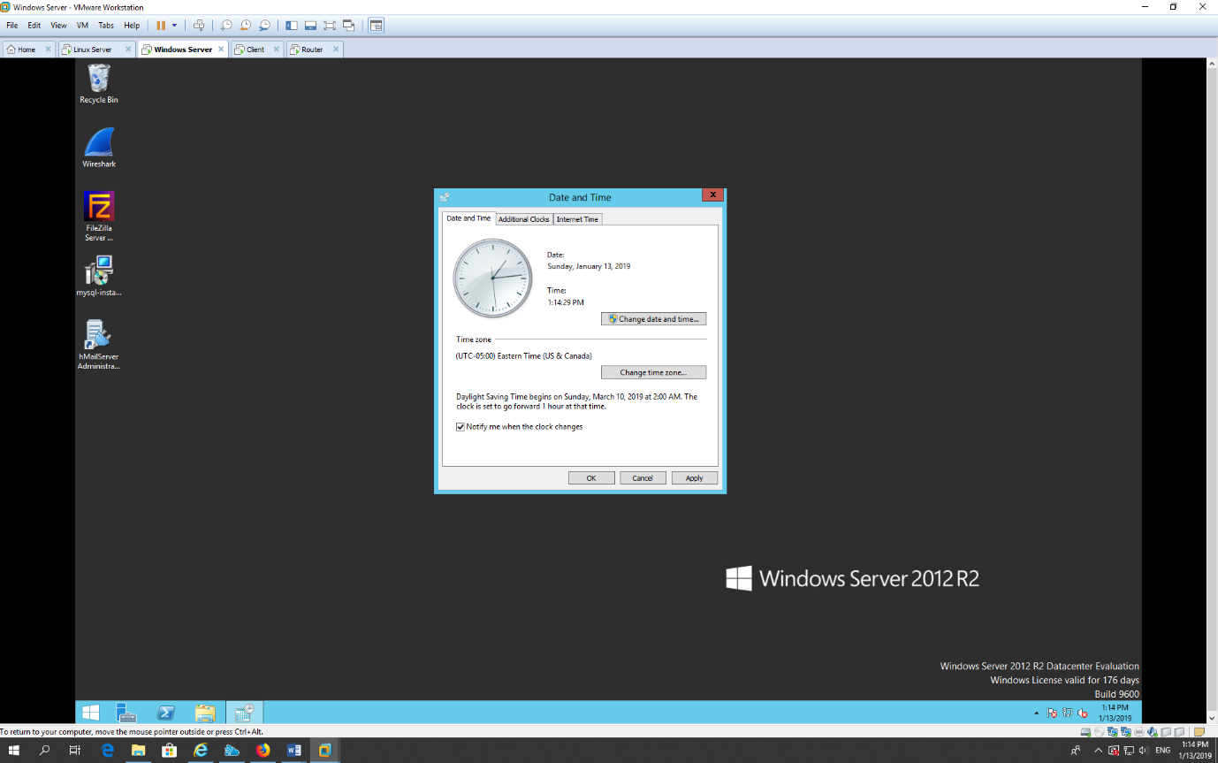

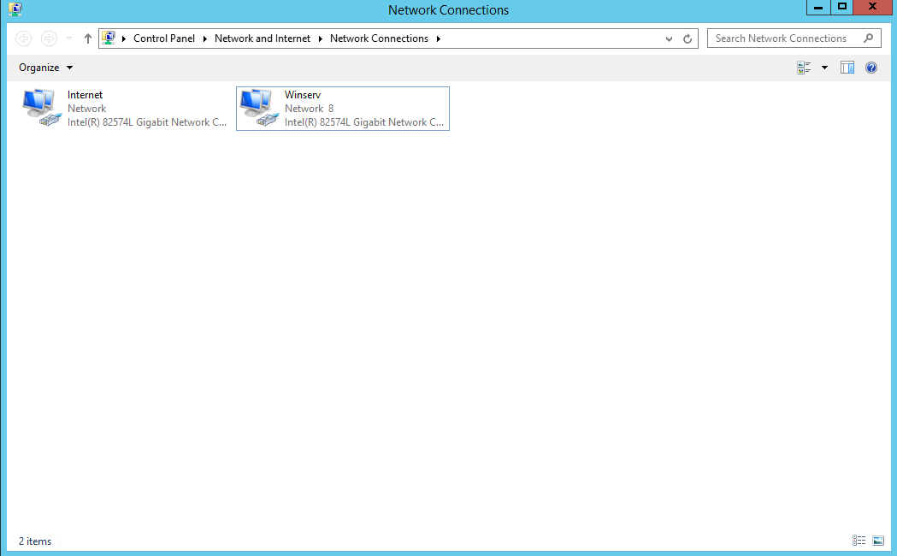

# Install and Setup Centos 7 as Client on VMware Workstation

## Install Client Machine

* Download the file image from MSDN website. Before start installing Windows Server, right click on VM, choose Setting. Add another Network Adapter. We have 2 network adapters, one for connecting to the Internet and another one for connecting to the Router.
* During Windows Server installation, all the these following information need to be assign correctly:
  + RAM: 2GB
  + Disk Space: 40GB
  + Time zone: GMT -5

## Basic setup

* Change the host name

**hostnamectl set-hostname client.vlha.com**

* Change the IP address:
* IP address of client will be assigned automatically from DHCP Server
* Turn off firewall: Turn off all the states of firewall

Open terminal and type these commands

**Yum install –y tcpdump**

**Yum install epel-release**

**Yum update –y && yum upgrade -y**

## Install software:

Open terminal and type these commands

**Yum install epel-release**

**Yum install –y tcpdump wireshark nmap**

**Yum update –y && yum upgrade –y**

## Grant permission to non-root user

Open terminal and type these commands

**Chmod +s /usr/sbin/tcpdump**

**Chmod +s /usr/sbin/dumpcap**

## Install Local Network LAN Segment

* Right click on VM and choose Setting, click Network Adapter, click Lan Segment. Assign Lan-Segment: Router-Client to Windows 2012 R2 machine.

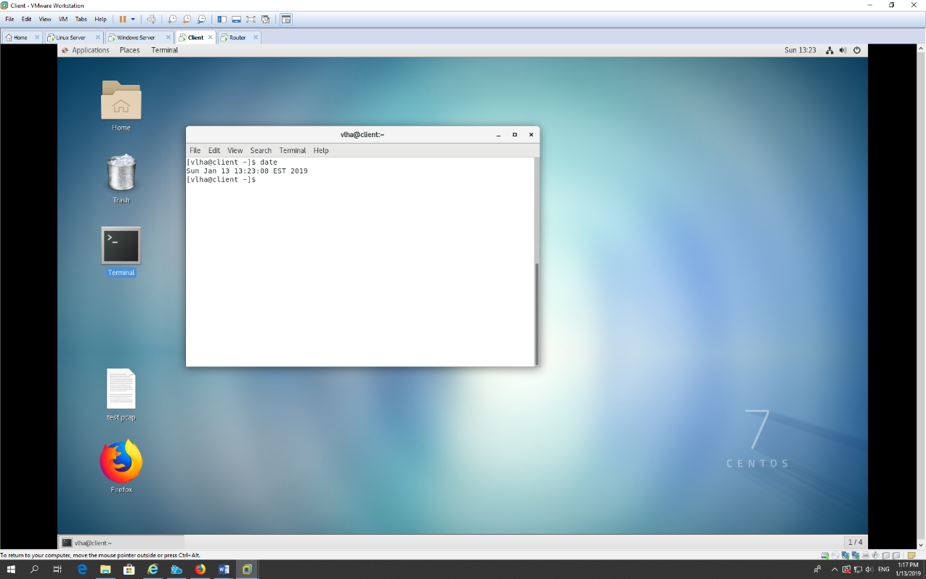

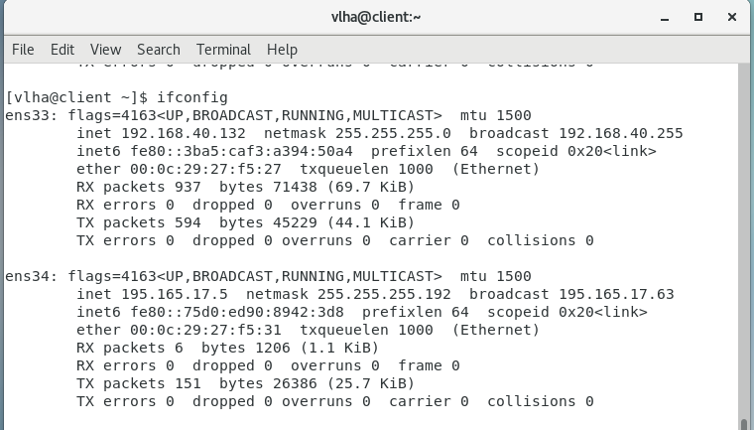

# Install and Setup Linux Machines as Linux Server

## Install Linux Server

* Download the file image from MSDN website. Before start installing Linux Server, right click on VM, choose Setting. Add another Network Adapter. We have 2 network adapters, one for connecting to the Internet and another one for connecting to the Router.
* During Linux Server installation, all of these following information need to be assign correctly:
  + RAM: 4GB
  + Disk Space: 30GB
  + Time zone: GMT -5

## Basic setup

* Change hostname:
* Login as root and type the command to change hostname:

**hostnamectl set-hostname lnxserv.vlha.com**

* Change IP address:

Edit the file /etc/sysconfig/network-scripts/ifcfg-ens34 to change the IP address

* IPADDR: 195.165.17.66
* NETMASK: 255.255.255.252
* GATEWAY: 195.165.17.65
* DNS1: 195.165.17.70
* ONBOOT=YES
* BOOTPROTO=static
* Turn off firewall:
* Type these commands to turn of firewall system

**Systemctl stop firewalld**

**Systemctl disable firewalld**

## Install software and update system

* Open terminal and type these commands

**Yum install –y tcpdump**

**Yum install epel-release**

**Yum update –y && yum upgrade -y**

## Grant permission to non-root user

Open terminal and type these commands

**Chmod +s /usr/sbin/tcpdump**

**Chmod +s /usr/sbin/dumpcap**

## Create a script to restart iptables

* Create a bash file with the command:

**touch cp1.bash**

* Edit the cp1.bash file and put all of these commands into the file:

#!/bin/bash

Iptables –F

Iptables –X

Iptables –P INPUT ACCEPT

Iptables –P OUTPUT ACCEPT

Iptables –P FORWARD ACCEPT

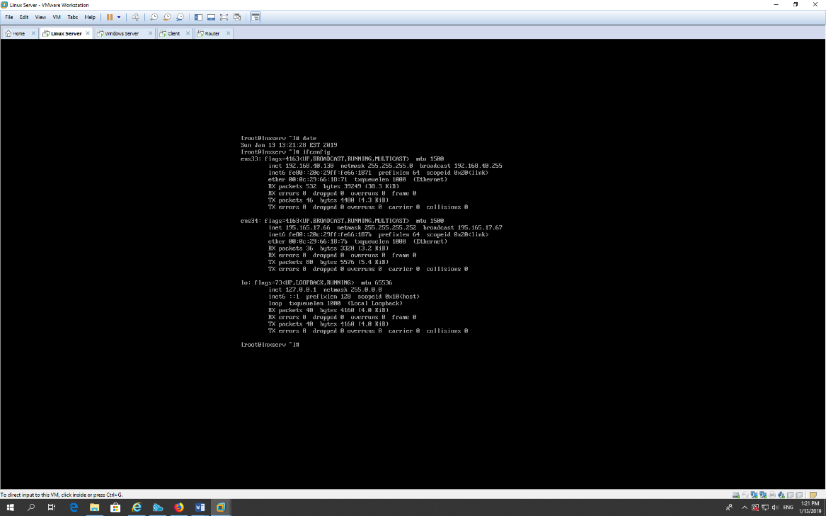

# Install and Setup Linux Machine as Router

## Install Router Machine

* Download the file image from MSDN website. Before start installing Linux Server, right click on VM, choose Setting. Add another Network Adapter. We have 4 network adapters, one for connecting to the Internet and the others to connect to Windows Server, Linux Server
* During Linux Server installation, all the these following information need to be assign correctly:
  + RAM: 4GB
  + Disk Space: 30GB
  + Time zone: GMT -5

## Basic setup

* Change hostname:
* Login as root and type the command to change hostname:

**hostnamectl set-hostname router.vlha.com**

* Change IP address:

Edit the file /etc/sysconfig/network-scripts/ifcfg-ens34 to change the ip address

* IPADDR: 195.165.17.62
* NETMASK: 255.255.255.192
* ONBOOT=YES
* BOOTPROTO=static

Edit the file /etc/sysconfig/network-scripts/ifcfg-ens35 to change the ip address

* IPADDR: 195.165.17.69
* NETMASK: 255.255.255.252
* ONBOOT=YES
* BOOTPROTO=static

Edit the file /etc/sysconfig/network-scripts/ifcfg-ens36 to change the ip address

* IPADDR: 195.165.17.65
* NETMASK: 255.255.255.252
* ONBOOT=YES
* BOOTPROTO=static
* Turn off firewall:
* Type these commands to turn of firewall system

**Systemctl stop firewalld**

**Systemctl disable firewalld**

## Install software and update system

* Open terminal and type these commands

**Yum install –y tcpdump**

**Yum install epel-release**

**Yum update –y && yum upgrade –y**

## Grant permission to non-root user

Open terminal and type these commands

**Chmod +s /usr/sbin/tcpdump**

## Create a script to restart iptables

* Create a bash file with the command:

**touch cp1.bash**

* Edit the cp1.bash file and put all of these commands into the file:

#!/bin/bash

Iptables –F

Iptables –X

Iptables –P INPUT ACCEPT

Iptables –P OUTPUT ACCEPT

Iptables –P FORWARD ACCEPT

